**Virtualisation and Cloud Computing**

CH01:

**Qn 01:::::::::::::::::::::::::Key Components of Cloud Infrastructure**

Cloud infrastructure is the foundation upon which cloud computing services are built. It comprises several essential components that enable the deployment, management, and scaling of applications. These components can be grouped into three main categories: **compute**, **storage**, and **networking**. Here are the key components:

1. **Compute Resources**:  
   Compute resources, often provided by **virtual machines (VMs)** or **containers**, allow users to run applications, process data, and execute tasks. Virtualisation plays a significant role here, allowing multiple virtual instances to run on a single physical server, thus maximizing resource utilization.
2. **Storage Systems**:  
   Cloud infrastructure includes scalable storage solutions, such as **block storage**, **object storage**, and **file storage**. This allows data to be stored, retrieved, and backed up efficiently. Cloud providers like Amazon S3 and Google Cloud Storage offer durable and scalable storage options.
3. **Networking**:  
   Networking in cloud infrastructure ensures connectivity between different components and users. It involves **virtual networks (VPCs)**, **load balancers**, **firewalls**, and **subnets**. These components help in secure data transmission, managing traffic, and connecting on-premises networks to the cloud.
4. **Virtualisation Layer**:  
   The virtualisation layer allows multiple operating systems and applications to share the same physical hardware while being isolated from each other. Hypervisors such as **VMware**, **KVM**, and **Xen** manage virtual machines, enabling flexibility and scalability in the cloud environment.
5. **Data Management and Databases**:  
   Cloud providers offer managed database services, such as **SQL** and **NoSQL** databases, to store and manage structured and unstructured data. These services provide automatic backups, scaling, and high availability.
6. **Security**:  
   Security is a critical component of cloud infrastructure. It includes **identity and access management (IAM)**, **encryption**, **firewalls**, and **intrusion detection systems (IDS)**. These measures ensure the protection of data and resources in the cloud.
7. **Automation and Orchestration**:  
   Cloud infrastructure leverages automation tools like **Ansible**, **Terraform**, and **Kubernetes** to manage resources and workflows efficiently. Orchestration ensures that resources are allocated and managed dynamically as per demand.
8. **Cloud Management and Monitoring**:  
   Cloud providers offer management tools like **AWS CloudWatch**, **Azure Monitor**, and **Google Cloud Operations** to monitor the performance, availability, and health of cloud resources. These tools provide insights into resource usage and help in troubleshooting issues.
9. **Content Delivery Networks (CDNs)**:  
   CDNs, such as **CloudFront** and **Akamai**, are used to distribute content globally, reducing latency and improving the performance of applications. They cache data in multiple geographic locations to ensure faster delivery.
10. **Elasticity and Scalability**:  
    Cloud infrastructure is designed to be elastic and scalable, meaning resources can be adjusted automatically based on workload demands. This is achieved through services like **auto-scaling** and **load balancing**, ensuring optimal performance and cost-efficiency.

Qn02::::::::::::::::::: **Layers and Types of Clouds**

Cloud computing refers to the delivery of computing services (such as servers, storage, databases, networking, software, etc.) over the internet, allowing users to access these resources on-demand. It eliminates the need for users to own and maintain physical data centers and hardware. Cloud computing relies on virtualization, which allows for efficient resource management by abstracting hardware from the software.

**2. Layers of Cloud Computing**

Cloud computing is structured in three primary layers, known as service models:

**a) Infrastructure as a Service (IaaS)**

This is the foundational layer that provides virtualized computing resources such as virtual machines, storage, and networking. Users can install operating systems, middleware, and applications on the provided infrastructure. **Examples**: AWS EC2, Google Compute Engine, Microsoft Azure.

**b) Platform as a Service (PaaS)**

PaaS provides a platform and environment for developers to build, test, and deploy applications without worrying about the underlying infrastructure. It typically includes an operating system, programming language execution environment, database, and web server. **Examples**: Google App Engine, Microsoft Azure App Services, Heroku.

**c) Software as a Service (SaaS)**

SaaS provides complete software solutions over the internet. End users can access and use these applications directly through a web browser, without managing the underlying infrastructure. **Examples**: Google Workspace (formerly G Suite), Microsoft Office 365, Salesforce.

**3. Types of Clouds**

There are four main types of clouds, each catering to different needs and user groups:

**a) Public Cloud**

Public clouds are owned and operated by third-party cloud service providers and are made available to the general public. Resources are shared among multiple users or tenants. **Examples**: Amazon Web Services (AWS), Microsoft Azure, Google Cloud.

**b) Private Cloud**

A private cloud is a cloud environment dedicated solely to one organization, either hosted on-site or by a third-party provider. It provides more control and privacy but is generally more expensive. **Example**: VMware-based private cloud solutions.

**c) Hybrid Cloud**

Hybrid clouds combine public and private clouds, allowing data and applications to be shared between them. This offers greater flexibility, optimization, and cost-efficiency by balancing workloads between the two environments. **Example**: A company using both its private data center and AWS services.

**d) Community Cloud**

This type of cloud is shared by several organizations with similar requirements, such as security needs or compliance regulations. It allows collaboration while maintaining privacy and data security. **Example**: Government clouds.

**Qn03::::::::::::::::::::::::::::::::::::: object storage and block storage**

**Object Storage**

**Definition:** Object storage is a data storage architecture that manages data as objects rather than as files in a hierarchy (as in file storage) or blocks (as in block storage). Each object typically includes the data itself, metadata, and a unique identifier.

**Characteristics:**

1. **Scalability**: Object storage is highly scalable, often used in cloud environments to handle massive amounts of unstructured data.
2. **Metadata**: Rich metadata is stored with the object, which helps in indexing, searching, and managing data.
3. **Access**: Data is accessed via APIs (e.g., AWS S3, Google Cloud Storage) rather than a traditional filesystem interface.
4. **Durability and Redundancy**: Object storage systems are designed to be fault-tolerant and provide redundancy by storing multiple copies of data across locations.

**Use Cases**:

* Backup and archival
* Storing multimedia files (videos, images)
* Web content and big data analytics

**Advantages**:

* Suitable for handling large volumes of data
* Can store unstructured data efficiently
* Easy to access from anywhere via the internet

**Example**: AWS S3, Google Cloud Storage

**Block Storage**

**Definition:** Block storage is a low-level storage architecture where data is stored in fixed-sized chunks or blocks. Each block is given an address, and data is stored and retrieved based on this address. The storage system operates at the disk level.

**Characteristics:**

1. **Performance**: Provides high I/O performance, especially for applications requiring low-latency access, such as databases.
2. **Flexibility**: Allows fine-grained control over storage, ideal for structured data that requires fast access.
3. **Operating System Integration**: Block storage is treated like a physical hard drive by the operating system, making it more suitable for running virtual machines or databases.
4. **Limited Metadata**: Block storage doesn’t have rich metadata; data is only identified by its block address.

**Use Cases**:

* Databases
* Virtual machine disk storage
* Applications requiring low latency and high throughput

**Advantages**:

* High performance for read/write operations
* Works well with transactional systems and structured data
* Integrates seamlessly with operating systems and virtualization platforms

**Example**: Amazon Elastic Block Store (EBS), Google Persistent Disk

**Comparison:**

| **Aspect** | **Object Storage** | **Block Storage** |
| --- | --- | --- |
| **Data Structure** | Objects with metadata | Fixed-size blocks |
| **Access Protocol** | API-based (HTTP/HTTPS) | Block-level access through OS |
| **Scalability** | Highly scalable for unstructured data | Scalable, but requires more management |
| **Performance** | Suitable for high-volume, large files | High performance for transactional data |
| **Metadata** | Rich metadata | Minimal metadata |

QN 04 :::::::::::::::::::::::::::::::::::: **Architecture of Cloud Computing**

[Architecture of Cloud Computing - GeeksforGeeks](https://www.geeksforgeeks.org/architecture-of-cloud-computing/)

UNIT 02

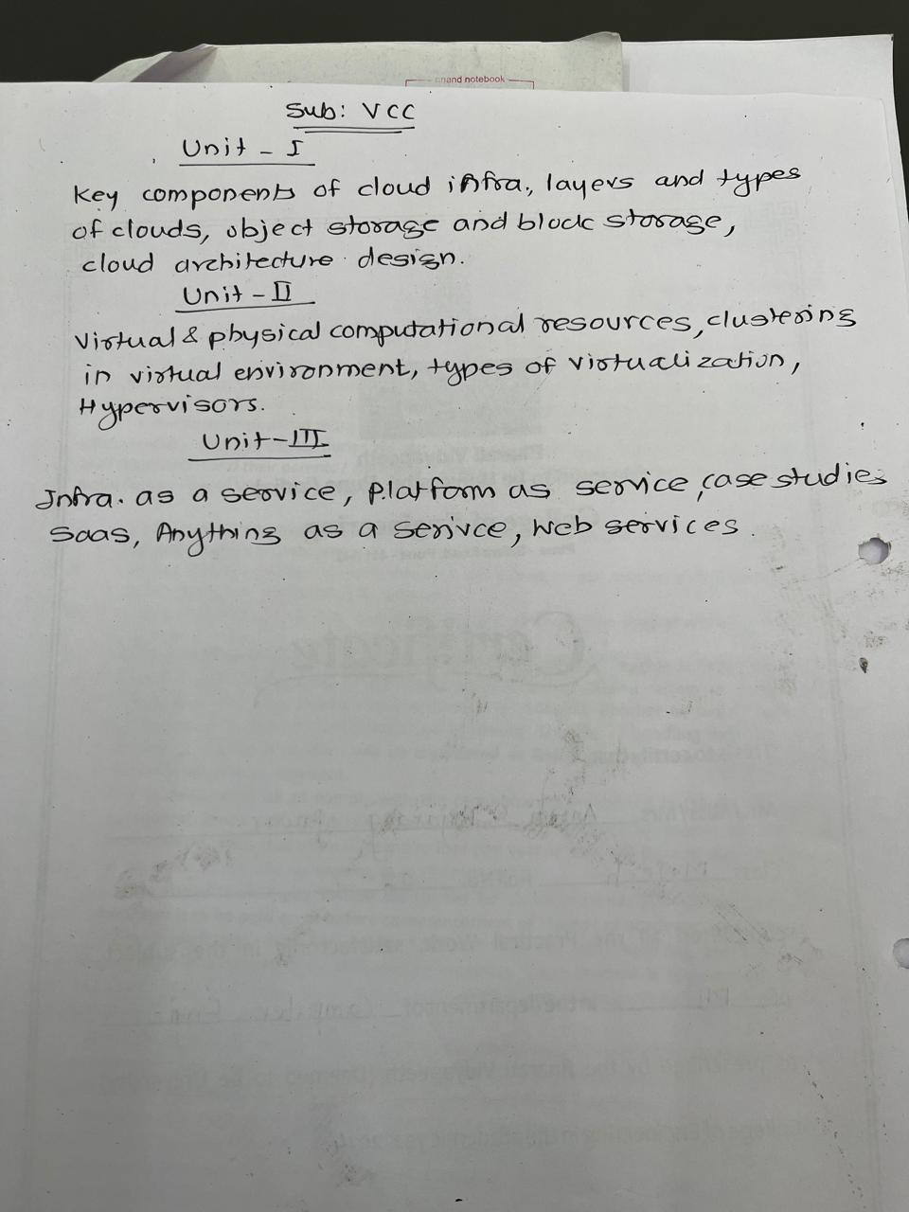

**Cloud Resources: Virtual and Physical Computational Resources**

Cloud computing provides access to various computational resources that are divided into two main categories: **virtual** and **physical** resources.

1. **Physical Computational Resources**:
   * These are the tangible hardware elements that make up the infrastructure of the cloud. Physical resources include:
     + **Servers**: Large data centers house physical servers that provide storage, compute power, and network resources. These servers are often arranged in clusters and can serve many users simultaneously.
     + **Networking Components**: Switches, routers, and physical network interfaces provide the connectivity required to link servers, storage, and users to the cloud.
     + **Storage Devices**: Hard disks and solid-state drives (SSDs) provide the physical infrastructure to store data in a cloud environment.
     + **Power and Cooling Systems**: To maintain the hardware and ensure uptime, data centers have power backups and sophisticated cooling systems.
   * **Example**: Amazon Web Services (AWS) operates physical data centers across the globe, providing the backbone of their cloud services.
2. **Virtual Computational Resources**:
   * Virtual resources are software-based versions of physical resources, created using virtualization technology. These resources are:
     + **Virtual Machines (VMs)**: These are software implementations of physical computers, running their own operating systems and applications, created by a hypervisor from the physical server’s resources. Each VM acts independently, providing compute power to users.
     + **Virtual Networks**: These abstract the physical network, allowing for isolated, scalable, and flexible network configurations without the need to modify physical hardware.
     + **Virtual Storage**: Data stored in virtual volumes, pools, or object storage systems that abstract the physical storage devices.
     + **Hypervisors**: These are software layers that enable virtualization by dividing physical hardware into multiple virtual resources. Examples include VMware, Hyper-V, and KVM.
   * **Example**: Microsoft Azure and Google Cloud use virtual machines (VMs) to offer scalable and flexible compute resources to customers on demand.

**Differences between Physical and Virtual Resources:**

* **Flexibility**: Virtual resources can be easily provisioned, scaled, and reallocated based on demand, whereas physical resources require more manual intervention.
* **Efficiency**: Virtualization improves resource utilization by enabling multiple VMs to run on a single physical server.
* **Cost**: Cloud providers offer virtual resources on a pay-as-you-go basis, making them more cost-efficient than maintaining physical infrastructure.

**Importance of Virtual and Physical Resources in Cloud Computing:**

* **Scalability**: The ability to scale up or down virtual resources quickly based on the workload is one of the main reasons for cloud adoption.
* **Cost Efficiency**: Users do not need to invest in costly physical infrastructure but can use virtualized resources on a subscription basis.
* **Resource Optimization**: Virtualization helps in optimizing the usage of physical hardware by running multiple virtual instances on the same physical resource.

QN02:::::::::::::::::::::::::::::::::::::::::::::::::::::::::::::::;;

**Clustering in Virtual Environment** (10 Marks)

**Introduction:** Clustering in a virtual environment refers to the grouping of multiple servers or virtual machines (VMs) to work as a single unit, providing high availability, scalability, and fault tolerance. This approach is commonly used in cloud computing and virtualization technologies to ensure better resource utilization and system performance.

**1. Key Concepts of Clustering:**

* **Cluster**: A collection of independent systems (servers or VMs) that work together as a single system.
* **High Availability (HA)**: Clustering ensures that if one node fails, another node takes over, minimizing downtime.
* **Load Balancing**: Distributes workloads across multiple nodes to optimize resource usage and prevent overload.
* **Failover**: The process of automatically transferring control to another node in case of failure.

**2. Types of Clustering:**

* **High-Availability Clusters**: Ensure that services remain available even in the event of hardware or software failures. This is achieved by having redundant nodes.
* **Load Balancing Clusters**: Distribute workloads among several servers to avoid overloading a single server, which improves performance.
* **High-Performance Computing (HPC) Clusters**: Combine the power of multiple servers to handle large-scale computing tasks, often used in scientific research or big data analysis.

**3. Virtualization and Clustering:** In a virtualized environment, VMs are used instead of physical servers for clustering. The virtualization layer abstracts the hardware, allowing multiple VMs to run on a single physical server or across several servers. The benefits of clustering in a virtual environment include:

* **Resource Efficiency**: Optimizes the use of CPU, memory, and storage resources across the cluster.
* **Scalability**: VMs can be easily added to or removed from the cluster as demand changes.
* **Isolation**: VMs within a cluster are isolated from one another, enhancing security and fault tolerance.

**4. Cluster Management Tools:** Several tools are available for managing clusters in virtual environments, including:

* **VMware vSphere HA**: Provides high availability and load balancing for virtualized environments.
* **Microsoft Failover Clustering**: Offers HA for virtualized Windows environments.
* **Kubernetes**: Used for managing clusters of containers, primarily in cloud-native applications.

**5. Benefits of Clustering in Virtualization:**

* **Redundancy**: Ensures systems remain operational even if individual nodes fail.
* **Cost-Effectiveness**: Optimizes the use of existing resources, reducing the need for additional hardware.
* **Flexibility**: VMs can be migrated across physical servers without affecting the performance of the cluster.
* **Efficient Maintenance**: Allows administrators to perform maintenance on one node while the cluster continues operating

QN 03:::::::::::::::::::::::::::::::::::::::::::::::::::::::::::::::::::::::;

In **Virtualization and Cloud Computing**, virtualization refers to the creation of a virtual version of something, such as hardware platforms, storage devices, or network resources. Here are the **types of virtualization**

**1. Hardware Virtualization**

* In hardware virtualization, a virtual machine (VM) is created on top of the physical hardware. This allows multiple operating systems to run concurrently on a single physical machine.
* **Example:** Hypervisors like VMware ESXi, Microsoft Hyper-V, and Xen enable this kind of virtualization.

**2. Operating System Virtualization**

* Also called **Containerization**, OS virtualization allows multiple isolated user-space instances (containers) to run on a single host OS kernel.
* **Example:** Docker and LXC (Linux Containers) are common platforms for OS virtualization.

**3. Desktop Virtualization**

* This allows users to access a desktop environment remotely or from any device, while the actual OS runs on a server.
* **Example:** Virtual Desktop Infrastructure (VDI) such as VMware Horizon and Citrix Virtual Apps and Desktops.

**4. Network Virtualization**

* Network virtualization abstracts physical network resources and creates virtual networks that can be managed and optimized independently.
* **Example:** Software-Defined Networking (SDN) and Network Function Virtualization (NFV) are key technologies in network virtualization.

**5. Storage Virtualization**

* This combines multiple physical storage devices into a single virtual storage pool, improving efficiency and flexibility.
* **Example:** Logical Volume Manager (LVM) and storage area networks (SAN) provide storage virtualization.

**6. Application Virtualization**

* Application virtualization allows an application to run in an isolated environment without direct installation on the local system.
* **Example:** Microsoft App-V and VMware ThinApp allow applications to be virtualized.

**7. Server Virtualization**

* In server virtualization, multiple virtual servers run on a single physical server, each acting like an independent server.
* **Example:** VMware vSphere and Microsoft Hyper-V support server virtualization.

**8. Data Virtualization**

* Data virtualization provides a virtual data layer that integrates data from various sources without needing to move or replicate the data.
* **Example:** Tools like Denodo and Red Hat JBoss Data Virtualization provide this capability.

**9. Memory Virtualization**

* Memory virtualization creates a pool of memory resources by combining physical memory from multiple systems and making it available to virtual environments.
* **Example:** Solutions like VMware vSphere allow memory overcommitment, a form of memory virtualization.

**10. GPU Virtualization**

* GPU virtualization enables sharing of the graphics processing unit (GPU) across multiple virtual machines.
* **Example:** NVIDIA GRID and AMD MxGPU provide GPU virtualization in data centers.

QN 04:::::::::::::::::::::::::::::::::::::::::::::::::::

A hypervisor, also known as a Virtual Machine Monitor (VMM), is a key technology in virtualization. It allows multiple operating systems (OS) to share a single hardware host, making each OS think it has the hardware entirely to itself. The hypervisor controls the host processor and resources, allocating what each OS needs. There are two main types of hypervisors:

**1. Type 1 Hypervisor (Bare Metal)**

* **Directly installed on hardware:** Type 1 hypervisors are installed directly onto the physical hardware, bypassing the need for a host OS. Examples include VMware vSphere/ESXi, Microsoft Hyper-V, and Citrix XenServer.
* **Efficient and secure:** Since there’s no host OS, these hypervisors offer better performance and reduced latency. They’re typically used in data centers and enterprise environments where high efficiency is needed.

**2. Type 2 Hypervisor (Hosted)**

* **Runs on a host OS:** Type 2 hypervisors require a base operating system. They run as an application on top of the host OS, and the VMs run within the hypervisor. Examples include VMware Workstation and Oracle VirtualBox.
* **More flexible but less efficient:** Type 2 hypervisors are easy to install and use on personal computers. However, because they rely on the underlying OS, they are generally less efficient compared to Type 1 hypervisors.

**Functions of Hypervisors:**

* **Resource Management:** Hypervisors manage CPU, memory, and disk space across all VMs to ensure optimal performance.
* **Isolation:** VMs are isolated from each other, preventing one VM’s failure from affecting others.
* **Scalability:** Hypervisors allow the deployment of multiple VMs on a single machine, improving hardware utilization and scalability.
* **Migration:** Many hypervisors support live migration, which means moving VMs between physical hosts without downtime.

**Benefits of Hypervisors:**

* **Cost Efficiency:** Organizations can consolidate their hardware by running multiple virtual environments on fewer physical machines.
* **Flexibility and Testing:** Hypervisors allow for easy testing of different operating systems and configurations without affecting the underlying physical hardware.
* **Disaster Recovery:** Virtual machines can be backed up and restored quickly, enabling efficient disaster recovery.